St. Joseph's Chapel

Holy Eucharist

Holy Baptism

Holy Confirmation

Holy Confession and Absolution

Holy Unction (healing oils)

Holy Orders

Benediction

Counseling

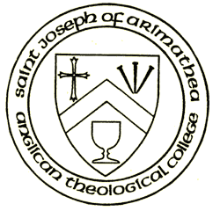

Holy Eucharist with choir and organ: 11:30 a.m., Sundays

Live-streamed at Facebook.com/sjachapel

(for changes and special celebrations, please visit sjachapel.org or sjachapel Facebook)

The Rt. Rev. Donald Ashman, Provost
The Very Rev. M. David Napier
Vicar and Dean
The Rev. Matthew Weber,
Chaplain-in-Residence
Mr. Eugene Petrushansky,
Organist and Broadcast Master

Confessions and counseling by appointment

2543 Durant Avenue (corner of Bowditch)
P.O. Box 40020
(Office) 510-841-3083, sjatc@sbcglobal.net, www.sjachapel.org
www.anglicanpck.org

St. Joseph of Arimathea
Collegiate Chapel

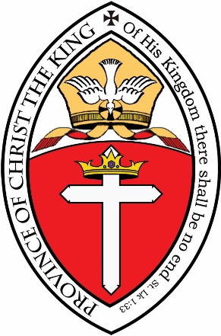

Praying
for the university
and Berkeley community,
for peace and freedom, since 1976,
on the corner of
Durant and Bowditch,
one block from campus

An Invitation

to
students, visitors, and the Berkeley community

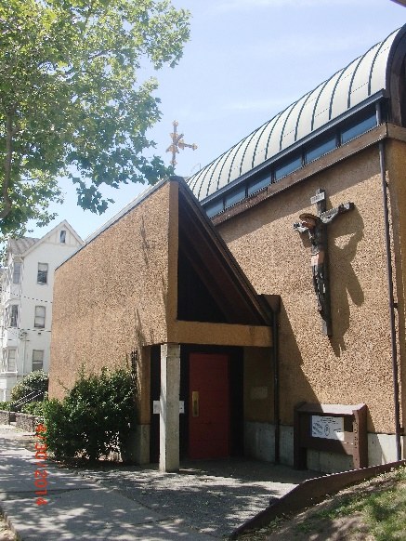

We invite you to worship with us in our inspiring St. Joseph of Arimathea Chapel, on the corner of Durant and Bowditch, one block from campus. We pray together, for one another, for the university, for Berkeley, for peace and freedom.

Our services are traditional Anglican (Episcopal), using the 1928 Book of Common Prayer. We worship our loving God – our Heavenly Father, Jesus Christ the Son, and the Holy Spirit – in the beauty of holiness, with candles, bells, and incense. We offer sung Eucharists, solemn processions, booming organ, and traditional hymns, all to the glory of God in this university setting, as a witness to historic Anglican Christianity.
The Cal Rowing Team (the "Crew") reside on our property and serve as acolytes during the academic year.
In addition to the Holy Eucharist, we offer rites of Baptism, Confirmation, Confession, Anointing the Sick, and Holy Orders. Counseling is available by appointment.

A warm family community gathers on Sundays, and we welcome you to join us in the worship of God, in the peace of holiness, and afterwards for light refreshments.

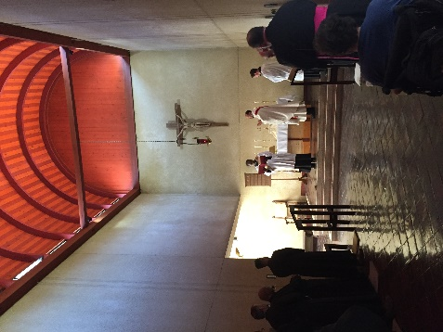

St. Joseph's Chapel is a barrel-vaulted collegial church (with a choir and sanctuary but without the usual parish nave). The high narrow space and the clerestory windows recall Early Christianity.

St. Joseph's Organ, built by the renowned Herr Ahrend, is played by music students in seasonal concerts as well as in Sunday services.

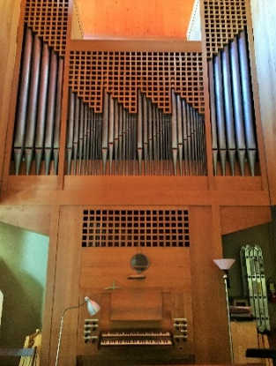
3.22

