Celebrate Christmas
at St. Peter's

The Living Crèche
(Christmas Pageant)

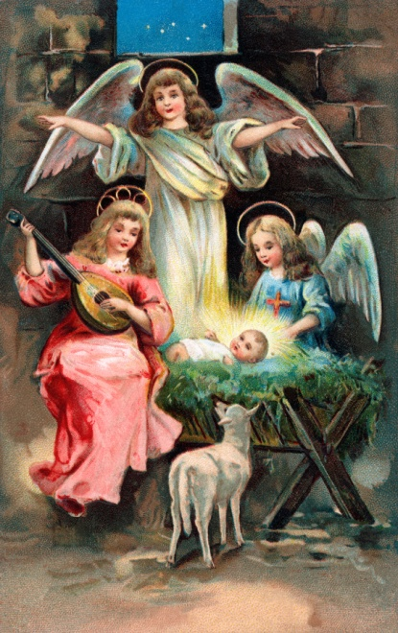

Lessons and Carols in a holy setting
Sunday, December 17, 10 a.m.

Children & teens wishing to take part contact Chris@Christinesunderland.com
Rehearsal: December 10, 2017, 10 a.m.
Saint Peter's Traditional Anglican Church
6013 Lawton (corner of Broadway in Rockridge), Oakland
510-597-1400, www.SaintPetersOakland.com, St.Peters.Oakland@gmail.com

