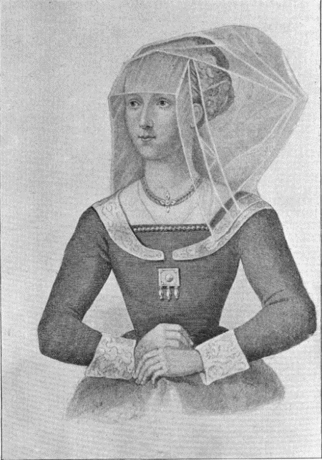
St. Peter's Anglican Church

is honored to sponsor

"Elizabeth Woodville Grey, the White Queen: the Wars of the Roses through Her Eyes"

Come witness the events that immediately preceded the birth of the Anglican Church.

Our 45 minute recitation includes video clips from the hit BBC/Starz TV series “The White Queen”. We begin with England after the Hundred Years War and birth of Elizabeth Woodville in 1436, and end with the Houses of York and Lancaster joining to create the House of Tudor and end the Wars of the Roses. Elizabeth Woodville Grey was ancestral mother to eleven English, Scottish, and French kings and queens, including Henry VIII and Elizabeth I. She led a life of adversity, bravery, and intrigue.

Cast Members include: Queen Elizabeth - Peggy Stevens; King Edward IV - Bud Warder (a descendant of Elizabeth Woodville Grey); Narrator - Kim Crow; Earl of Warwick & Lord Hastings - The Reverend Michael Mautner

Sunday, September 24, 2017, 11:30 a.m.

Light refreshments provided

No charge, but please RSVP as we only have room for the first 40 signups:
Email Peggy - peggy@kioskamerica.com; Call or Text Bud - 925-998-6603

St. Peter's Anglican Church
6013 Lawton (corner of Broadway), Rockridge, Oakland
510-597-1400, St.Peters.Oakland@gmail.com, www.saintpetersoakland.com

